**A**

**Module Name**

**1**

# Heading1

## A.1.1 Heading2

### A.1.1. a Heading3

Ros is the desawy task that will make the robot walk Ros is the desawy task that will make the robot walk Ros is the desawy task that will make the robot walk Ros is the desawy task that will make the robot walk Ros is the desawy task that will make the robot walk Ros is the desawy task that will make the robot walk Ros is the desawy task that will make the robot walk Ros is the desawy task that will make the robot walk Ros is the desawy task that will make the robot walk Ros is the desawy task that will make the robot walk Ros is the desawy task that will make the robot walk Ros is the desawy task that will make the robot walk Ros is the desawy task that will make the robot walk Ros is the desawy task that will make the robot walk Ros is the desawy task that will make the robot walk [A.1]

Figure . Eldesouky before diet

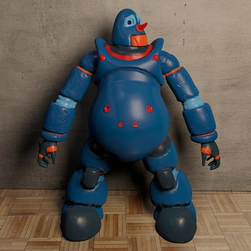

[This Photo](https://www.flickr.com/photos/pizzaso/5835620897) by Unknown Author is licensed under [CC BY](https://creativecommons.org/licenses/by/3.0/)

Figure . Eldesouky after diet



[This Photo](https://freepngimg.com/png/35751-robot-file) by Unknown Author is licensed under [CC BY-NC](https://creativecommons.org/licenses/by-nc/3.0/)